**PROCEDURE:**

**Query #1**

Marketing wants to find out which products get ordered together, particularly in **threes**. Report out the sets of three products that get ordered together in the same customer order and the total number of orders that show all three of those products. Be sure that the same three products do not show up more than once. For instance, there should not be one row in your output with product A,B, and C and then another row with the products B, C, and A. Order the output by the number of orders that the three products occur together, in descending order. Only show those combination of products that appear in more than 20 orders. Returns 56 rows.

There are (as always) several ways to approach this. For this exercise, please do this by joining three subqueries together. Each of the inline queries will just require a join between orderDetails and Products

SELECT c.productcode1, c.productcode2, c.productcode3,count(*) as times_bought_together

FROM (

SELECT a.productcode as productcode1, b.productcode as productcode2, z.PRODUCTCODE as productcode3

FROM orderdetails a

INNER join orderdetails b

ON a.ordernumber = b.ordernumber AND a.productcode > b.productcode

INNER JOIN orderdetails z

ON z.ordernumber = a.ORDERNUMBER AND z.ordernumber = b.ORDERNUMBER AND a.PRODUCTCODE > z.productCode AND b.productCode > z.productCode) c

GROUP BY c.productcode1, c.productcode2, c.productcode3

HAVING count(*) > 20

order by times_bought_together desc

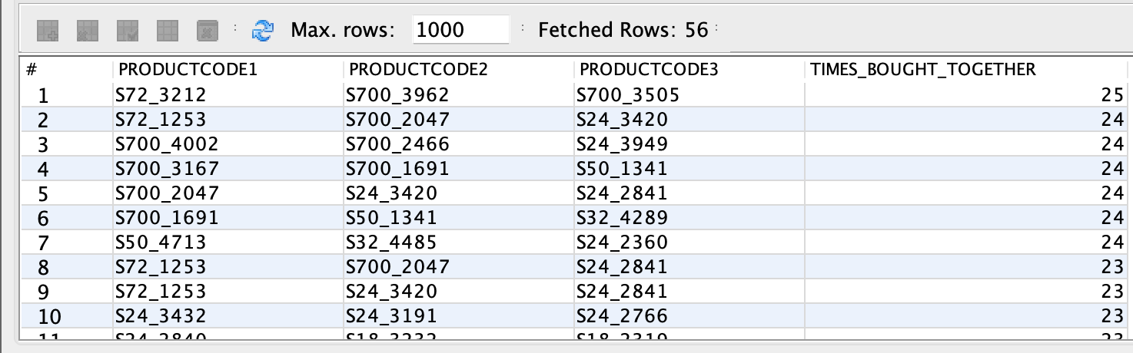

CREATE VIEW ordersOfThree AS

SELECT a.productcode as productcode1, b.productcode as productcode2, z.PRODUCTCODE as productcode3

FROM orderdetails a

INNER join orderdetails b

ON a.ordernumber = b.ordernumber AND a.productcode > b.productcode

INNER JOIN orderdetails z

ON z.ordernumber = a.ORDERNUMBER AND z.ordernumber = b.ORDERNUMBER AND a.PRODUCTCODE > z.productCode AND b.productCode > z.productCode;

SELECT ordersOfThree.productcode1, ordersOfThree.productcode2, ordersOfThree.productcode3,count(*) as times_bought_together

FROM ordersOfThree

GROUP BY ordersOfThree.productcode1, ordersOfThree.productcode2, ordersOfThree.productcode3

HAVING count(*) > 20

order by times_bought_together desc;

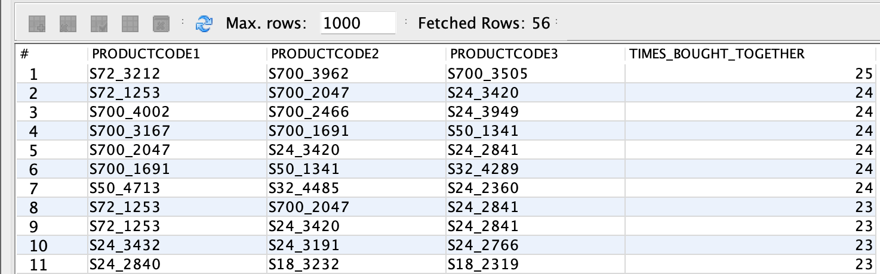

**Query #2**

Find each pair of customers and the products that they have **both** ordered for all pairs of customers who have ordered the same product during the **first two months of 2015**. Do not repeat customer pairs. You will want to create two subqueries that join customers to orders to order details to products. Order by the first customer name, then the second customer name, then the name of the product that they have ordered in common. Returns 84 rows.

SELECT DISTINCT cust1.CustomerName, cust2.CustomerName, cust1.ProductName

FROM (SELECT CustomerName, ProductName FROM Customers

INNER JOIN Orders o ON o.CUSTOMERNUMBER = Customers.CUSTOMERNUMBER

INNER JOIN OrderDetails od ON od.ORDERNUMBER = o.ORDERNUMBER

INNER JOIN Products p ON p.PRODUCTCODE = od.PRODUCTCODE

WHERE o.ORDERDATE >= '2015-01-01' AND o.ORDERDATE < '2015-03-01') cust1

INNER JOIN (SELECT CustomerName, ProductName FROM Customers

INNER JOIN Orders o ON o.CUSTOMERNUMBER = Customers.CUSTOMERNUMBER

INNER JOIN OrderDetails od ON od.ORDERNUMBER = o.ORDERNUMBER

INNER JOIN Products p ON p.PRODUCTCODE = od.PRODUCTCODE

WHERE o.ORDERDATE >= '2015-01-01' AND o.ORDERDATE < '2015-03-01') cust2 ON cust1.PRODUCTNAME = cust2.PRODUCTNAME

WHERE cust1.CUSTOMERNAME > cust2.CUSTOMERNAME;

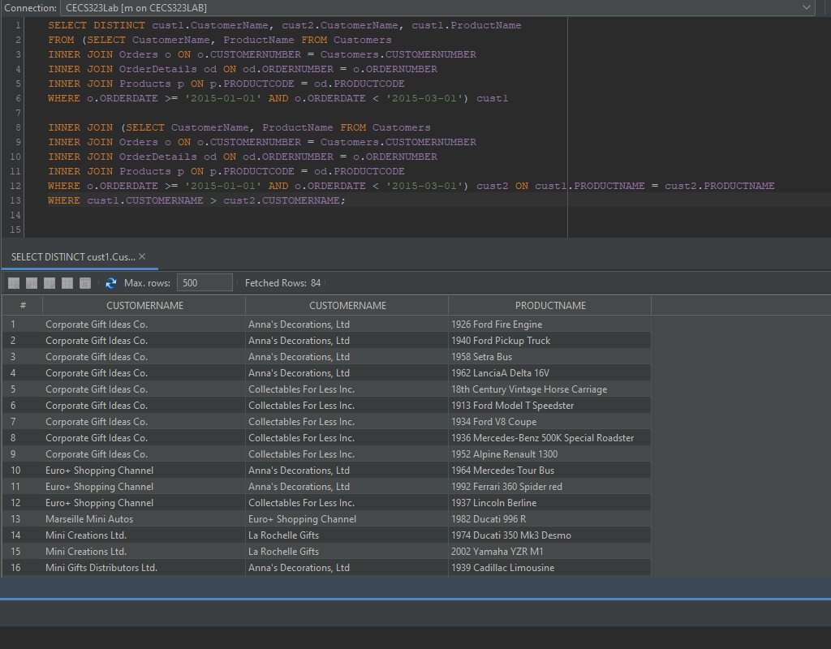

_____________________________________________________________________________________

CREATE VIEW FirstTwoMonthsOrders AS

SELECT CustomerName, ProductName FROM Customers

INNER JOIN Orders o ON o.CUSTOMERNUMBER = Customers.CUSTOMERNUMBER

INNER JOIN OrderDetails od ON od.ORDERNUMBER = o.ORDERNUMBER

INNER JOIN Products p ON p.PRODUCTCODE = od.PRODUCTCODE

WHERE o.ORDERDATE >= '2015-01-01' AND o.ORDERDATE < '2015-03-01';

SELECT DISTINCT cust1.CustomerName, cust2.CustomerName, cust1.ProductName

FROM FirstTwoMonthsOrders cust1 INNER JOIN FirstTwoMonthsOrders cust2 ON cust1.PRODUCTNAME = cust2.PRODUCTNAME

WHERE cust1.CUSTOMERNAME < cust2.CUSTOMERNAME;

